NOTICE OF MEETING

You are summoned to attend the next meeting of March Town Council which will take place on Monday 1 April 2019 in the Skoulding Suite at the Town Hall commencing at 7.15pm.
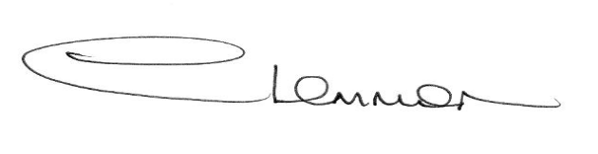C. LEMMON
TOWN CLERK

- Apologies for Absence.

- Peter Catchpole, Fenland District Council,
Corporate Director & Chief Finance Officer.

- Police Update.

- Planning Applications. Enc.

- Public Participation.

- Minutes of the Meeting held on:
4 March 2019 – Council Meeting Enc.
18 March 2019 – Planning Sub-Committee Meeting Enc.
18 March 2019 - Christmas Lights Working Party Meeting Enc.

- Matters Arising.

- Estover Update/Additional Funding

- Cambridgeshire County Council - Councillor Update.

- Fenland District Council Update - Cllr. Kit Owen.

- Schedule of Accounts.

