NOTICE OF MEETING

You are summoned to attend the next meeting of March Town Council which will take place on Monday 1 February 2016 in the Skoulding Suite at the Town Hall commencing at 7.15pm.
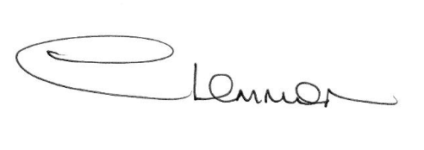C. LEMMON TOWN CLERK
- Apologies for Absence.

- Michael Holt – Environmental Health Officer, Fenland District Council.

- Police Update.

- Planning Applications. Enc.

- Public Participation.

- Minutes of the Meeting held on:
4 January 2016 – Council Meeting Enc.
18 January 2016 – Planning Sub-Committee Enc.

- Matters Arising.

- Her Majesty the Queen’s 90th birthday celebrations – Cllr Jan French.

- Flooding Update.

- Cambridgeshire County Council - Councillor Update.

- Fenland District Council Update - Cllr. Kit Owen.

- Schedule of Accounts.

