NOTICE OF MEETING

You are summoned to attend the next meeting of March Town Council which will take place on Monday 3 April 2017 in the Skoulding Suite at the Town Hall commencing at 7.15pm.
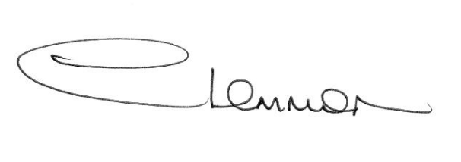C. LEMMON
TOWN CLERK
- Apologies for Absence.

- Police Update.

- Planning Applications. Enc.

- Public Participation.

- Minutes of the Meeting held on:
6 March 2017 – Council Meeting Enc.
20 March 2017 – Planning Sub-Committee Enc.
20 March 2017 – Christmas Lights Working Party Meeting Enc.

- Matters Arising.

- Cambridgeshire County Council - Councillor Update.

- Fenland District Council Update - Cllr. Kit Owen.

9. Schedule of Accounts.

