NOTICE OF MEETING

You are summoned to attend the next meeting of March Town Council which will take place on Monday 3 August 2015 in the Skoulding Suite at the Town Hall commencing at 7.15pm.
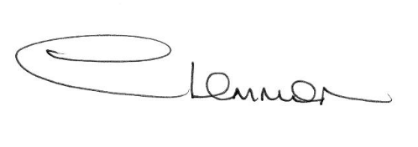C. LEMMON
TOWN CLERK
- Apologies for Absence.

- Police Update.

- Planning Applications. Enc.

- Public Participation.

- Minutes of the Meeting held on:
6 July 2015 – Council Meeting Enc.
20 July 2015 – Planning Sub-Committee Meeting Enc.
20 July 2015 – Christmas Lights Working Party Meeting Enc.

- Matters Arising.

- Local Highway Improvement Initiative 2016/17

- Civil Protection and Emergency Preparedness – Cllr A Pugh

- Flooding Update.

- Cambridgeshire County Council - Councillor Update.

- Fenland District Council Update.

- Schedule of Accounts.

