NOTICE OF MEETING

You are summoned to attend the next meeting of March Town Council which will take place on Monday 4 December 2017 in the Skoulding Suite at the Town Hall commencing at 7.15pm.
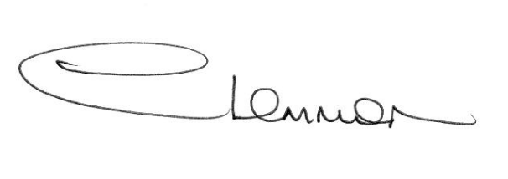C. LEMMON
TOWN CLERK
- Apologies for Absence

- Police Update

- Planning Applications Enc.

- Public Participation

- Minutes of the Meeting held on:
6 November – Council Meeting Enc.
20 November – Planning Sub-Committee Meeting Enc.
20 November – Christmas Lights Working Party Meeting Enc.

- Matters Arising

- Grants and Donations Enc.

- Local Highway Improvement 2018/19

- Budget 2018/19

- Cambridgeshire County Council - Councillor Update

- Fenland District Council Update - Cllr. Kit Owen

- Schedule of Accounts

