NOTICE OF MEETING

You are summoned to attend the next meeting of March Town Council which will take place on Monday 4 September 2017 in the Skoulding Suite at the Town Hall commencing at 7.15pm.
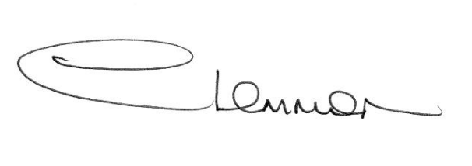C. LEMMON
TOWN CLERK
- Apologies for Absence
- Welcome to our guests from Japan
- Police Update

- Planning Applications Enc.

- Public Participation

- Minutes of the Meeting held on:
7 August – Council Meeting Enc.
21 August – Planning Sub-Committee Meeting Enc.

- Matters Arising

- Premises Licensing: a) West End Park
b) Market Place/Town Centre
- Public Toilets

- Local Highway Improvements application 2018/19

- Photocopier Upgrade

- Cambridgeshire County Council - Councillor Update

- Fenland District Council Update - Cllr. Kit Owen

14. Schedule of Accounts.

