NOTICE OF MEETING

You are summoned to attend the next meeting of March Town Council which will take place on Monday 5 June 2017 in the Skoulding Suite at the Town Hall commencing at 7.15pm.
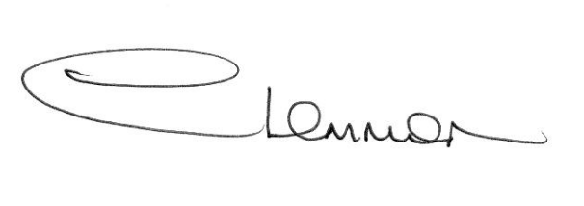C. LEMMON
TOWN CLERK
- Apologies for Absence.

- Police Update.

- Planning Applications. Enc.

- Public Participation.

- Minutes of the Meeting held on:
15 May 2017 – Annual Council Meeting Enc.

- Matters Arising.

- Schedule of Councillors for Band Concert Supervision 2017.

- Internal Audit Review to year ending 31 March 2017 and
Re-appointment of internal Auditors.

- Cambridgeshire County Council - Councillor Update.

- Fenland District Council Update - Cllr. Kit Owen.

11. Schedule of Accounts.

