NOTICE OF MEETING

You are summoned to attend the next meeting of March Town Council which will take place on Monday 2 March 2015 in the Skoulding Suite at the Town Hall commencing at 7.15pm.
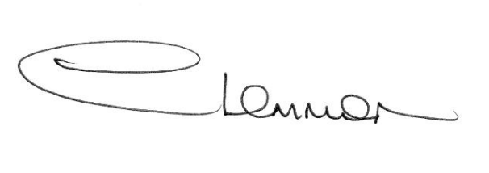C. LEMMON
TOWN CLERK
- Apologies for Absence.

- Youth and Community Coordinators – Donna Barnes, Cambridgeshire County Council.

- Police Update.

- Planning Applications. Enc.

- Public Participation.

- Minutes of the Meeting held on:
1 February 2016 – Council Meeting Enc.
15 February 2016 – Personnel and Administrative Sub-Committee Enc.
15 February 2016 – Planning Sub-Committee Enc.
15 February 2016 – Christmas Lights Working Party Meeting Enc.

- Matters Arising.

- Grants and Donations. Enc.

- Flooding Update.

- Cambridgeshire County Council - Councillor Update.

- Fenland District Council Update - Cllr. Kit Owen.

12. Schedule of Accounts.

