
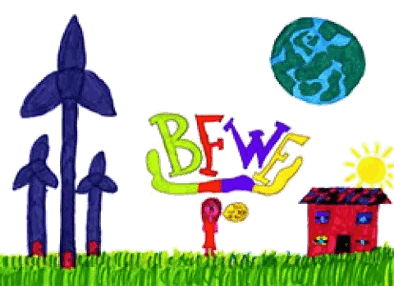
Burnthouse Farm
March Town Council
Community Fund Application Form

Name of organisation: ……………………………………………………….

Contact name: ……………………………………………………….

Role within organisation: ……………………………………………………….

Contact address: ……………………………………………………….

Contact email: ……………………………………………………….

Amount requested: £…………………

Please give details of how the grant would benefit your organisation (max 250 words).

If successful, please give details of bank account to be paid into:

Account name: ………………………………………
Sort Code: _ _ - _ _ - _ _
Account number: ………………………………………

Please note:
By signing and submitting this application you agree that:
- your organisation is happy to be part of any publicity regarding this funding;
- not all applications may be successful;
- any grant may be less than applied for.

Signed: …………………………….. Date: ………………………

Please return completed form to admin@marchtowncouncil.gov.uk or by hand/post to March Town Council, Town Hall, Market Place March PE15 9JF

